Sure, here’s a detailed roadmap for learning HTML and web development:
- HTML Basics: Start with understanding what HTML is and its basic elements such as headings, paragraphs, links, images, etc¹².
- HTML Layout and Editors: Learn about HTML layout and different editors you can use¹.
- HTML Attributes: Understand various HTML attributes like class, id, title, style, height, src, and alt¹.
- HTML Lists: Get familiar with ordered and unordered lists in HTML¹.
- HTML Input Fields and Forms: Learn about HTML input tag, form tag, form attribute, and forms¹.
- HTML Tables: Understand how to create tables in HTML¹.
- HTML Graphics: Learn about SVG basics and HTML canvas¹.
- HTML Media: Understand how to use media attribute, video, and audio tag in HTML¹.
- HTML 5 MathML: Learn about MathML introduction, math tag, multiscript tag, semantics tag, notation attribute, and movable limits attribute in HTML5¹.
- Hyperlinks: Learn how to create hyperlinks².
- Text Formatting Techniques: Explore different techniques to format text².
- Media Integration: Learn how to integrate media into your HTML documents².
- Client-Side Form Validation: Understand how to create client-side form validation².
- Tables: Learn how to create tables in HTML².
- Common Attributes: Explore common attributes in HTML².
- Semantic HTML Elements: Master the use of semantic HTML elements².
- Web Accessibility: Learn how to integrate web accessibility into your HTML documents².
- Advanced HTML Concepts: Delve into advanced HTML concepts².
Remember, practice is key when learning HTML. Try to build simple web pages as you learn new concepts. This will help reinforce what you’ve learned and gain hands-on experience. Happy learning!

HTML Paragraphs(block element)

HTML Tag Reference:
Table of Content
- Properties of the paragraph tag
- br tag :break the line (move curser to next line)
- hr tag :a horizontal line btwn 2 para
- align attribute : align the text (left, right, centre)
- pre tag : show written para as it is

HTML Style Tag
<style>
/* CSS properties applied inside
this style tag */
</style>

Table of Content
- Hexadecimal Style
- RGB Style
- RGBA Style
- HSL Color
- HSLA Color

Block Level Elements:
A block-level element always starts on a new line and stretches out to the left and right as far as it can i.e, it occupies the whole horizontal space of its parent element & the height is equal to the content’s height.

Supported tags:
- <address> Tag
- <blockquote> Tag
- <dd> Tag
- <Div> Tag
- <dl> Tag
- <dt> Tag
- <canvas> Tag
- <form> Tag
- <Heading> Tag
- <hr> Tag
- <li> Tag
- <main> Tag
- <nav> Tag
- <noscript> Tag
- <ol> Tag
- <pre> Tag
- <section> Tag
- <tfoot> Tag
- <ul> Tag
- Tables Tag
- HTML Paragraphs
- <Video> Tag
- <aside> Tag
- <article> Tag
- <figcaption> Tag
- <fieldset> Tag
- <figure> Tag
- <footer> Tag
- <header> Tag

Inline Elements:
An inline element is the opposite of the block-level element. It does not start on a new line and takes up only the necessary width ie., it only occupies the space bounded by the tags defining the HTML element, instead of breaking the flow of the content.

Supported tags:
- <br> Tag
- <button> Tag
- <time> Tag
- <tt> Tag
- <var> Tag
- <a> Tag
- <abbr> Tag
- <acronym> Tag
- <b> Tag
- <cite> Tag
- <code> Tag
- <dfn> Tag
- <em> Tag
- <i> Tag
- <output> Tag
- <q> Tag,
- <samp> Tag
- <script> Tag
- <select> Tag
- <small> Tag
- <span> Tag
- <strong> Tag
- <sub> Tag
- <sup> Tag
- <textarea> tag
- <bdo> Tag
- <big> Tag
- <img> Tag
- <input> Tag
- <kbd> Tag
- <label> Tag
- <map> Tag
- <Object> tag
M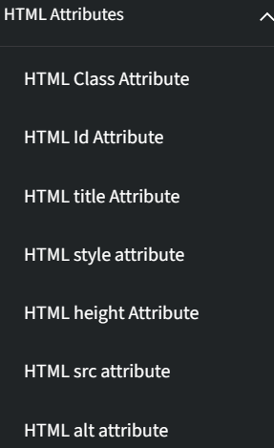tyle Tag

- √ colours link: click here
- HTML Table Borders (w3schools.com)
- HTML Table Colgroup (w3schools.com)
- HTML Layout Elements and Techniques (w3schools.com) very very important
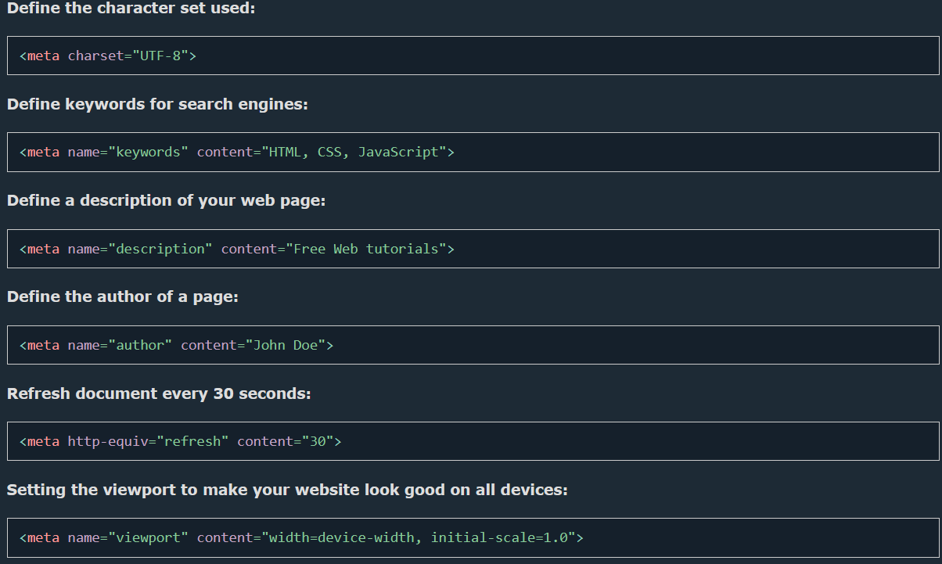
HTML Responsive Web Design
- Setting The Viewport
- Responsive Images
- <img src="img_girl.jpg" style="max-width:100%;height:auto;">
- <picture>
<source srcset="img_smallflower.jpg" media="(max-width: 600px)">
<source srcset="img_flowers.jpg" media="(max-width: 1500px)">
<source srcset="flowers.jpg">
<img src="img_smallflower.jpg" alt="Flowers">
</picture
- Responsive Text Size
- <h1 style="font-size:10vw">Hello World</h1>
- Media Queries
Chapter Summary
The <kbd> element defines keyboard input
The <samp> element defines sample output from a computer program
The <code> element defines a piece of computer code
The <var> element defines a variable in programming or in a mathematical expression
The <pre> element defines preformatted text
Semantic Elements in HTML
Below is a list of some of the semantic elements in HTML.
Tag | Description
<article> | Defines independent, self-contained content
<aside> | Defines content aside from the page content
<details> | Defines additional details that the user can view or hide
<figcaption> | Defines a caption for a <figure> element
<figure> | Specifies self-contained content, like illustrations, diagrams, photos, code listings, etc.
<footer> | Defines a footer for a document or section
<header> | Specifies a header for a document or section
<main> | Specifies the main content of a document
<mark> | Defines marked/highlighted text
<nav> | Defines navigation links
<section> | Defines a section in a document
<summary> | Defines a visible heading for a <details> element
<time> | Defines a date/time

HTML Symbols:
For html entities click me
HTML Uniform Resource Locators:
For theory of URL click me 🫡
HTML Encoding (Character Sets)
For charset click me

Important elements use as professional:
<b> <strong>
<i> <em >
<object> <embed >
<mark> - Marked text
<small> - Smaller text
<del> - Deleted text
<ins> - Inserted text
<sub> - Subscript text
<sup> - Superscript text
<blockquote>,<q>, <abbr>, <address>, <cite>, and <bdo>
Use style attribute instead of direct giving styles
Always give alt attribute in image tag
For multiple images give picture tag for flexible page
Remember about bg images in style attribute
Advanced tables (ex. Nth -child, colgroup,)
Iframe target topic

forms
Input Restrictions
Here is a list of some common input restrictions:
Attribute | Description
checked | Specifies that an input field should be pre-selected when the page loads (for type="checkbox" or type="radio")
disabled | Specifies that an input field should be disabled
max | Specifies the maximum value for an input field
maxlength | Specifies the maximum number of character for an input field
min | Specifies the minimum value for an input field
pattern | Specifies a regular expression to check the input value against
readonly | Specifies that an input field is read only (cannot be changed)
required | Specifies that an input field is required (must be filled out)
size | Specifies the width (in characters) of an input field
step | Specifies the legal number intervals for an input field
value | Specifies the default value for an input field

Center align a <div> element
If you have a <div> element that is not 100% wide, and you want to center-align it, set the CSS margin property to auto.
Example
<style>
div {
width:300px;
margin:auto;
}
</style>

Inline-block
⭐Instead of using float attribute we use inline-block display later we can use flex and grid
If you change the <div> element's display property from block to inline-block, the <div> elements will no longer add a line break before and after, and will be displayed side by side instead of on top of each other.
Example
How to use display: inline-block to align div elements side by side:
<style>
div {
width: 30%;
display: inline-block;
}
</style>
Note: While the value is not displayed to the user in the page's content, it is visible (and can be edited) using any browser's developer tools or "View Source" functionality. Do not use hidden inputs as a form of security!

Advance forms

https://www.w3schools.com/html/html_form_attributes_form.asp

